
Taller Pre Bimestrales Inglés (Review)

Colegio Campestre

Quizz

On August 25, 2024
- Choose the correct option.
"Being good at something means you're skilled or talented in it. For example, if you're good at playing the piano, you play very well. Which sentence uses 'good at' correctly?
Good at + Verb ing
  - She is good at running fast.
  - He is good in playing video games.

- In the story of "The Tortoise and the Hare," the main characters are:
The Hare – A swift and confident animal who believes he can easily win any race. | The Tortoise – A slow and steady animal who is determined and persistent despite being underestimated.
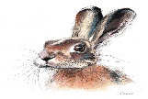 | 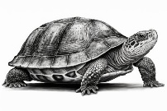
- Underline the book report of this text with these codes begging (red), middle (blue) and green (end)
Story of the Tortoise and the Hare.

The Hare bragged about being fast and challenged the Tortoise to a race. Confident, the Hare napped during the race. The Tortoise kept moving steadily and won. The story teaches that persistence and determination often lead to success.
Choose the correct option
- What did this story teach you?
  - Always run fast
  - Napping is important
  - Slow and steady can win the race
  - Never race

- Write these verbs in the past to present simple and its meaning in Spanish.

Present | Past
Go: ir | Went: fui
 | ate
 | Took
 | Played
 | Ran
 | Kept
 | Slept
 | Rested

